**Santec**

**IL Scanning Test System Sample**

**Software manual**

2023-04-19



# Project Overview

This is sample software for a swept test system for IL measurements.

|  |  |
| --- | --- |
| development environment (computer) | Labview 2017 |
| Instrument.DLL | Version 2.5.1 |
| STSProcess.DLL | Version 2.2.2 |
| NI DLL | 15.5 and its successors |

# configure

1. Tunable Laser TSL Series (TSL-550/TSL-710/TSL-570/ TSL-770)
2. Power Meter MPM Series (MPM-210/210H/211/212/213/215)

This sample software allows you to control up to two MPM hosts (MPM-210 or MPM-210H).

Communication settings

Tunable Laser (TSL) Control TSL-550/710: GPIB

TSL-570/ TSL-770: GPIB, TCP/IP, USB

* It can be changed on the source code. The initial value of the separator is CRLF.

Power Meter (MPM) Controls

MPM-210/210H: GPIB, TCP/IP and USB

connecting reference

Use a BNC cable to connect the following parts.

TSL-*** Trigger Output -> MPM-210H Trigger Input

TSL-*** Power Monitor -> MPM-210H TSL Monitor

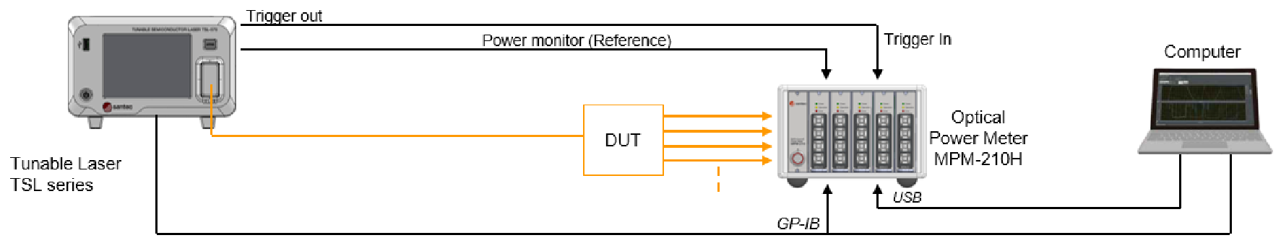

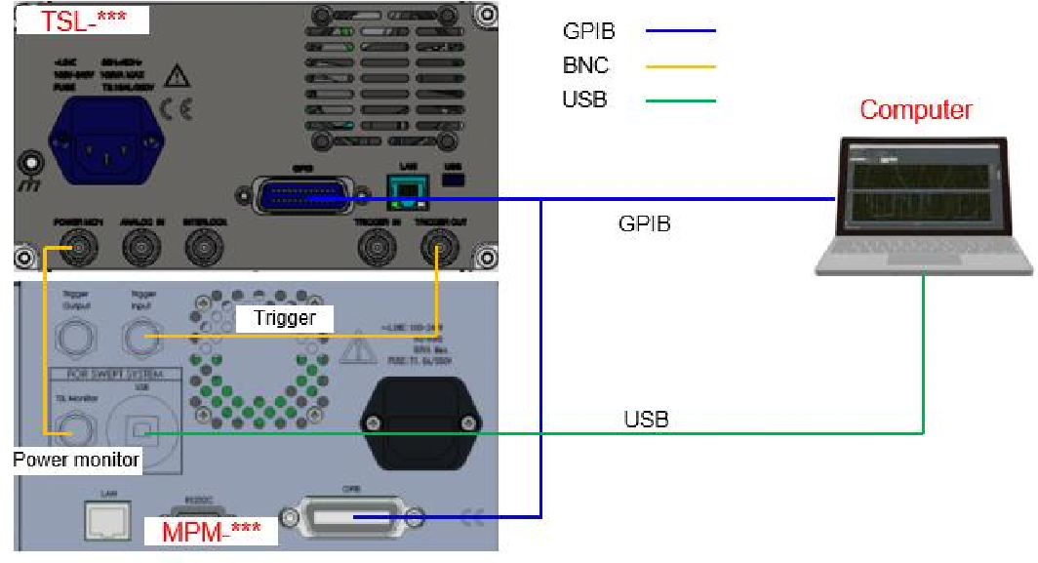

Figure 1.

# procedure

1. Instrument Setup Window

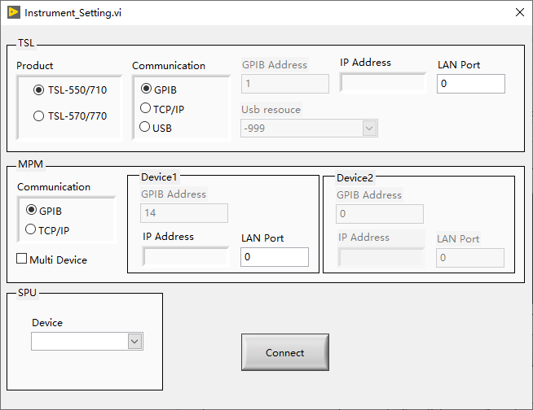

Figure 2. Instrument Setup Window

1. Functions - Instrument Settings   
    screen is used from the main window at startup. Expands each instrument's settings to the main window.
   1. Form Load

The SPU (DAQ) device number and USB resource (when the TSL-570 interface and PCU-110 interface are USB) connected to the PC are received from the main form and displayed in each Combobox control

* 1. TSL

Displaying TSL communication setting information

* 1. MPM

Displays information about the MPM's communication settings for up to two hosts

* 1. SPU

Displays the device number of the DAQ.

* 1. Connect

After setting up each measuring instrument in Figure 2, press the "Connect" button and the STS IL Demo software interface is shown in Figure 3.

1. STS IL Example

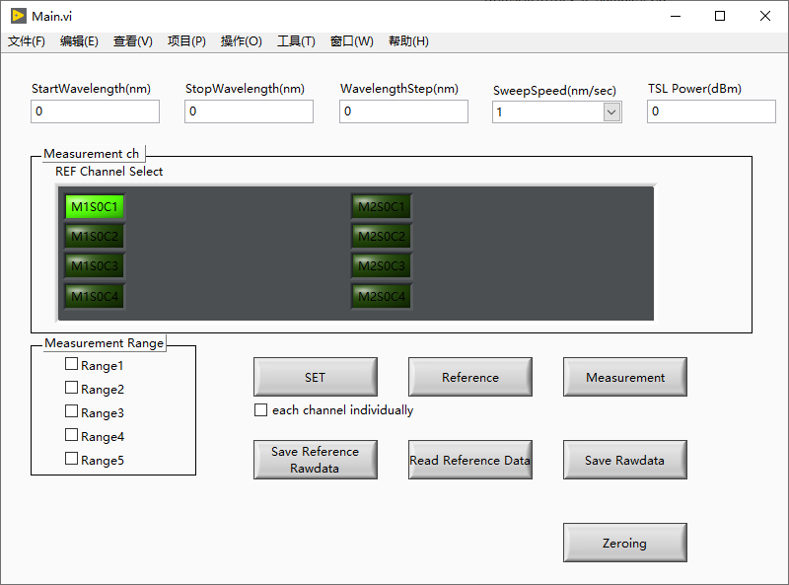

K. Zeroing

A.

Sweep

condition

set

t

ing

B.

Sweep

condition set

C. Reference

D. IL

measurement

I.Reference data Read out

E. Measurement ch setting

F. Reference Rawdata save

G. Rawdata save

H. Measurement range setting

J. each channel individually

Figure 3. IL-STS Sample Software Window

1. How to use
   1. Tunable Laser Settings  
       Enter scanning conditions in the Scan Setup (A) box

|  |  |  |
| --- | --- | --- |
| Starting wavelength (nm) | starting wavelength |  |
| Stop Wavelength(nm) | Stop Wavelength |  |
| Step wavelength(nm) | Measurement data step wavelength |  |
| Scanning speed (nm/s) | scanning speed |  |
| TSL Power (dBm) | TSL Output Power |  |

* 1. Power meter settings  
      Set Measurement ch (F) and Measurement Range (G) in the Measurement Channels and Range frame. Set the channels of the power meter module at Measurement ch (F). When multiple channels are selected, multiple devices on the channel under test (DUT) can be measured at the same time. Set the range for each scan at Measurement Range (G). When multiple ranges are selected, high dynamic range measurements can be performed. This function is effective when the dynamic range of the DUT is 40 dB or higher. A dynamic range of approximately 40 dB can be measured per scan.

Under the following conditions, the dynamic range of the DUT is set to 60 dB, the output power of the light source is set to 8 dBm, and the DUT is connected directly without the need to insert a splitter between the tunable devices laser (TSL) and power meter (MPM), the

Range number: 2

1st Range: Range 1

2nd Range: Range 4

* 1. Setting the set parameters to each instrument The set parameters are set to each instrument when the "SET(B)" button is clicked. The set parameters are passed to each instrument class and STS Process class. The STS data structure required to retain data in the STS process is also set.
  2. Reference data testing

When the "Reference (C)" button is clicked, Reference data is acquired under the conditions set in 1 and 2.

*When multiple measurement ranges are set, reference data is acquired in the first range. When multiple channels are selected and EACH CHANNEL INDIVIDUALLY(J) is checked, each channel acquires data individually for use at Reference(C).

* 1. Insertion Loss Test

After clicking the "Measure (D)" button, Insertion Loss (hereinafter referred to as IL) is tested under the conditions set in 1 and 2. When multiple measurement ranges are set, the Sweep process is performed with the number of ranges set, and the data is merged in the STS Process class. After that, the IL data is calculated and output as a file. Sweep processing is detailed in 4).

* 1. Reference Raw Data Preservation

Clicking the "Save Reference Rawdata (F)" button specifies the STS Data Struct when reading Reference Rawdata from the STS Process class. The Reference Rawdata is saved as a csv file in the specified path. When multiple channels are selected and each channel individually (J) is checked, the monitordata for each channel is saved separately.

* 1. Raw Data Retention

After the "Rawdata (G)" button, the measurement data is read by Measure (D) in the STS Process class. When the STS Data Struct is specified, the measurement data is saved as a csv file in the specified path.

* 1. Reference data reading

After reading the Reference data saved in 6.), this data is passed to the "STS Process" class. When multiple channels are selected and each channel individually(J) is selected, each channel needs its own monitordata when reading.

* 1. The connected MPM is electrically returned to zero.

5) Scanning Steps

1. Set TSL as the starting wavelength for measurement and set the MPM range.

2. Place the TSL in Trigger Signal Input Standby mode and start the scanning process.

3. MPM begins recording.

4. SPU started recording.

5. Issue a soft trigger for the TSL.

6. Wait for the SPU and MPM records to complete.

7. Wait for TSL scanning to complete.

8. Set TSL to the scan start wavelength.

9. Read the measurement data from the MPM and SPU and pass these data and the STS Data Struct to the "STS Process" class.

10. Perform data processing in the STS Process class.

*When multiple measurement ranges are set, data processing can be performed at once.

For multiple sweeps (acquiring multiple ranges), after executing process 9, check the busy status of the TSL and repeat from process 1.